**Wireframe Document**

**PRESCRIPTION LABEL READING**

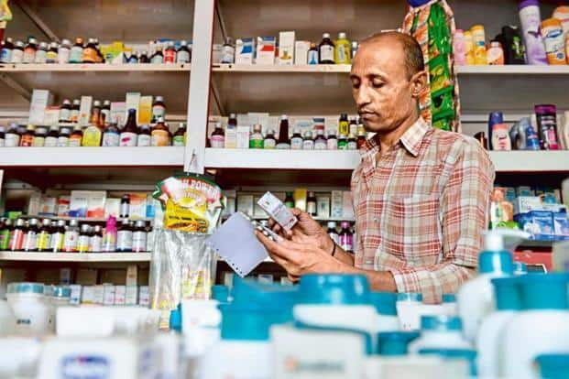

**Revision Number - 1.0**

**Last Date of Revision – 08-07-2022**

# Document Control

|  |  |  |  |  |
| --- | --- | --- | --- | --- |
| **Date** |  | **Version** | **Description** | **Author** |
| 30-08-2023 | 1.0 |  | Wireframe Documentation | Prashant Kadam |
| 31-08-2023 | 1.1 |  | Wireframe Documentation | Praful Chalakh |
|  |  |  |  |  |
|  |  |  |  |  |

**Need to add something{We Performed PADDLEOCR technique and gTTS.**

**Refer the notebook.}**